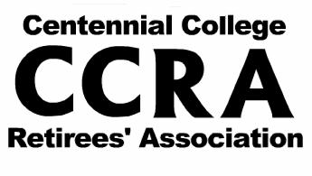  A G E N D A  CCRA 18th Annual General Meeting  Wednesday, October 9, 2019  Centennial College Event Center- 8th Floor  937 Progress Ave, Scarborough |  | Mission Statement  The Purpose / Mission of the Centennial College Retirees’ Association:  - The Centennial College Retirees’ Association is an organization whose purpose is to promote the interest of Centennial College retirees. It provides members with fellowship, pertinent information and response to their concerns.  It acts to:  - Promote continuing contact and dialogue among retired members of the Centennial College community through:  - Social and recreational events  - Formal communication such as through the CCRA website, newsletters, and mailings  - Advocate for Centennial College retirees  - Liaise with retire groups such as other community college retirees’ associations and the Ontario Colleges Retirees’ Association (OCRA)  - Promote the interests of Centennial College and its programs within the community Marilyn  - Maintain a formal relationship with the College at the Presidential level to ensure the continuity and independence of  CCRA  - Perform Directorsan active role where appropriate, with respect to wider social issues within the community
9:45 am | Registration & Refreshments
10:15 am | Welcome & Call to Order  Ellen Bull, President
10:30 am | Motion to approve the 2019 Agenda & 2018 Minutes of the 15th Annual General Meeting
10:40 am | 2018/19 Reports  (Questions are welcome following each report)  - President/Vice President Ellen Bull & Marilyn Scott  - Membership Chuck Baker  - Treasurer Yvonne Glenville  - Webmaster Yvonne Glenville  - Communication
11:10 am | OCRA Report Linda Choptiany, President
11:20 am | CCRA Logo & Website Ellen Bull & Marilyn Scott
 | Elections and Director Confirmations-
11:45 pm | Special Guest-  Dr. Craig Stephenson  President, Centennial College
12:00 pm | Wrap-Up and Adjournment
12:15 pm – 1:30 pm | Light Lunch & Door Prizes - Draw

