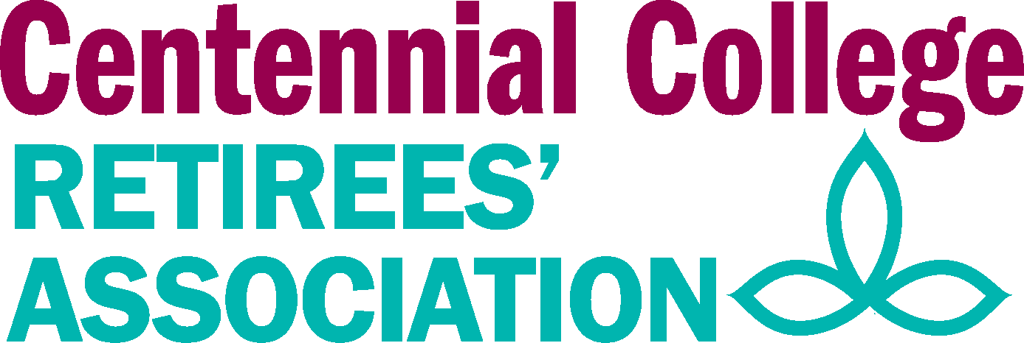  Monday September 14, 2020  10:30 A.M. – 12:00 P.M.  Zoom Tele-Meeting | Mission Statement  The Purpose / Mission of the Centennial College Retirees’ Association:  - The Centennial College Retirees’ Association is an organization whose purpose is to promote the interest of Centennial College retirees. It provides members with fellowship, pertinent information and response to their concerns.  It acts to:  - Promote continuing contact and dialogue among retired members of the Centennial College community through:  - Social and recreational events  - Formal communication such as through the CCRA website, newsletters, and mailings  - Advocate for Centennial College retirees  - Liaise with retire groups such as other community college retirees’ associations and the Ontario Colleges Retirees’ Association (OCRA)  - Promote the interests of Centennial College and its programs within the community  - Maintain a formal relationship with the College at the Presidential level to ensure the continuity and independence of  CCRA  - Perform an active role where appropriate, with respect to wider social issues within the community
- Welcome & Introductions

- Review & Acceptance of CCRA Sept 14, 2020 Agenda

- Review & Acceptance of Minutes from June 8, 2020

- Business Arising
  - New Membership Package-P. Lee & P. Brown
  - Directors and Officers Liability Insurance- M. Scott
  - Fall AGM- Oct. 21 (and COVID 19)
    - In-person meeting cancelled
    - Draft Executive Reports
    - Membership 2021

- Directors Reports
  - E. Bull –President, Treasurer
  - P. Brown– Membership
  - P. Lee– Events
  - L. Bidwell- Webmaster,
  - E. Zehethofer- Telephone Communications

- New Business
  - Sustainability Projects- M. Gauthier
  - Review/Renewal of Board Members

- Next Meeting Dates- Oct. 19, Nov. 9, 2020

