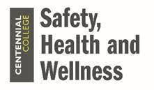 | Wellness Wednesday  December 16, 2020
COVID Fatigue and Essential Workers
COVID Fatigue or Pandemic Fatigue may include symptoms similar to anxiety, indifference and struggling to keep going with pandemic precautions. This can be especially difficult for those who have returned to campus, are restricted in their social connections, and required to wear PPE throughout their workday. Check out these 6 ways to overcome COVID Fatigue from the Heart and Stroke Foundation.
Workplace Resilience
Being resilient means having the capacity to overcome adversity. With the unique challenges introduced during the pandemic, even the most resilient workers may be struggling to maintain their mental wellness. Here are some ways to Build Your Personal Resilience from Psychology Today. For more information on resilience, our EFAP provider Morneau Shepell has 10 Tips to increase your resiliency:
1. Build supportive relationships
2. Have an optimistic outlook
3. Accept change
4. Trust your judgement
5. Keep things in perspective
6. Work through the problem
7. Acknowledge small gains
8. Know your stress triggers
9. Strengthen your coping skills
10. Take care of yourself
Isolation during the Holidays
This holiday season, due to restrictions on travel and social gatherings, many people will experience feelings of isolation from their family and friends. This article offers six recommendations for Coping with isolation during the holidays.

Physical Health
There are many benefits to being physically active throughout the workday including, stress reduction, increased positive mood, improved cognitive functioning, and improved physical health. Here are some links for physical activities:
- Progressive Muscle Relaxation (PMR) – 5-minute PMR meditation
- Take a Dance Break

Nutrition
As the new year approaches, many of us will take the opportunity to set new goals and begin a healthy eating routine.

Preparing healthy meals to enjoy while at work can be challenging, but following the Canada Food Guide’s recommendations and utilizing some of the Tips and Recipes provided in this article from the Academy of Culinary Nutrition can get you started.
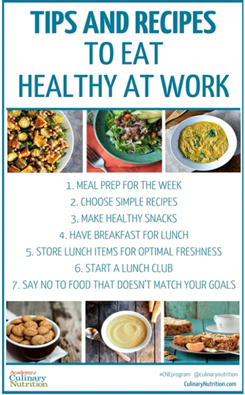
.

Winter Driving Tips
This winter most people will be driving less with the restrictions on travel, dining out, events and activities. With less time spent on the road, drivers may be out of practice or not as vigilant when driving in challenging winter conditions. Click the link above to review some winter driving tips from the Canadian Safety Council.

Staying Safe on Public Transit
When taking public transit in the winter, remember to take extra precautions to prevent slips, trips and falls. Wear appropriate footwear, dress for weather conditions and follow the TTC Travelling Safely guidelines.

Mindful Breaks
Taking a mindful break will not only give your mind and body a break but will also help to improve your overall resilience, cognitive processing and boost your energy throughout the day.

“Calming activities can help release stress and help to refocus your attention so that you can really work on tasks at hand.”
- Try these Calming Techniques
- 5-minute meditation you can do anywhere
- Try using an app during your mindful breaks such as
  - Calm
  - Headspace
  - Insight

